QUANTUM SCATTERING REPORT
Yifeng CHEN
999016959

Part 1 — Free Gaussian wave packet
The free Gaussian wave model is,
ψ(0,x) = (2a/π)¹ᐟ⁴ exp[−a(x−x₀)²] exp[i p₀(x−x₀)].

1.1 Changing the width
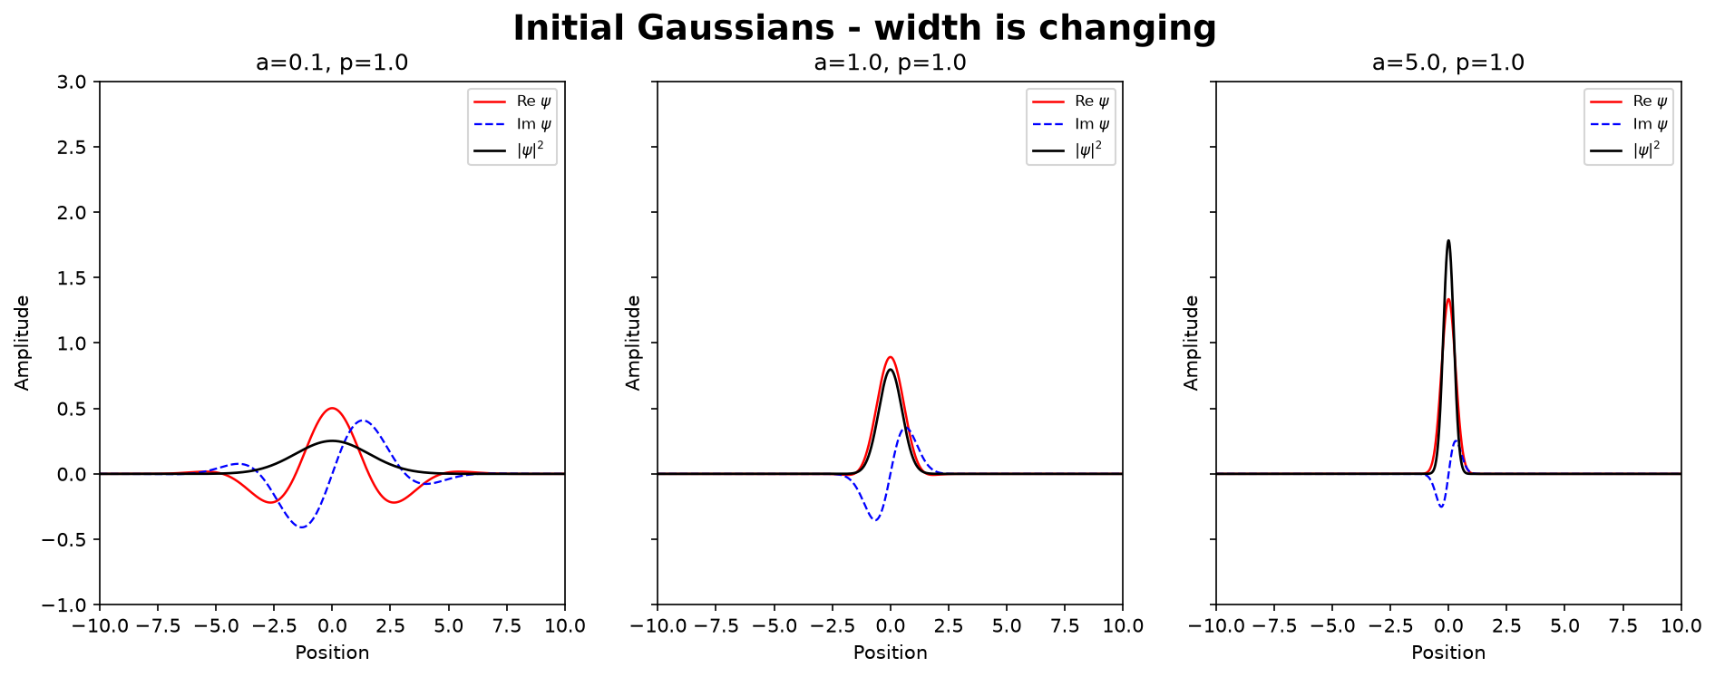
Figure 1. Initial Gaussian states for a = 0.1, 1, and 5 with p₀ = 1.
Here p0 = 1 is fixed, increasing a makes the probability distribution narrower in real space, and also the wave is narrower. This is because Δx=1/(2√a) at t=0.

1.2 Changing the mean momentum
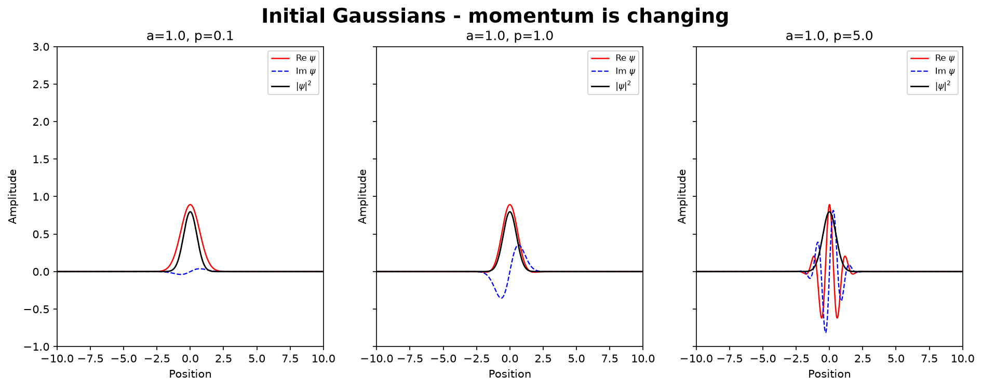
Figure 2. Initial Gaussian states for p₀ = 0.1, 1, and 5 with a = 1.
When a is fixed, a larger p₀ makes the real and imaginary parts oscillate more rapidly inside the same envelope. However, the Gaussian probability distribution, |ψ|², is unchanged when p₀ is varied.

1.3 Free propagation
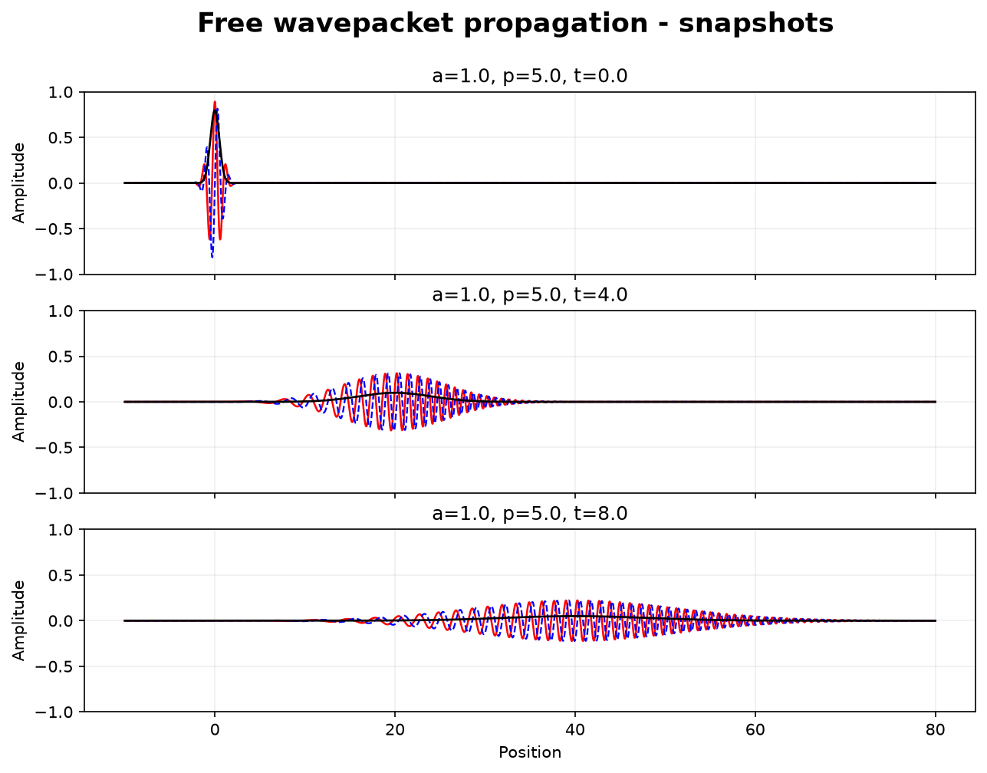
Figure 3. Free propagation for a = 1 and p₀ = 5 at t = 0, 4, and 8.
For t>0, the whole Gaussian wave moves to the right with a center velocity equaling p₀/m. At the same time the packet also spreads, so the Gaussian wave also becomes wider as time increase.

Part 2 — Regularized Dirac delta function
The approximation function of Dirac delta function used in the project is
δL(p) = sin(Lp)/(πp).

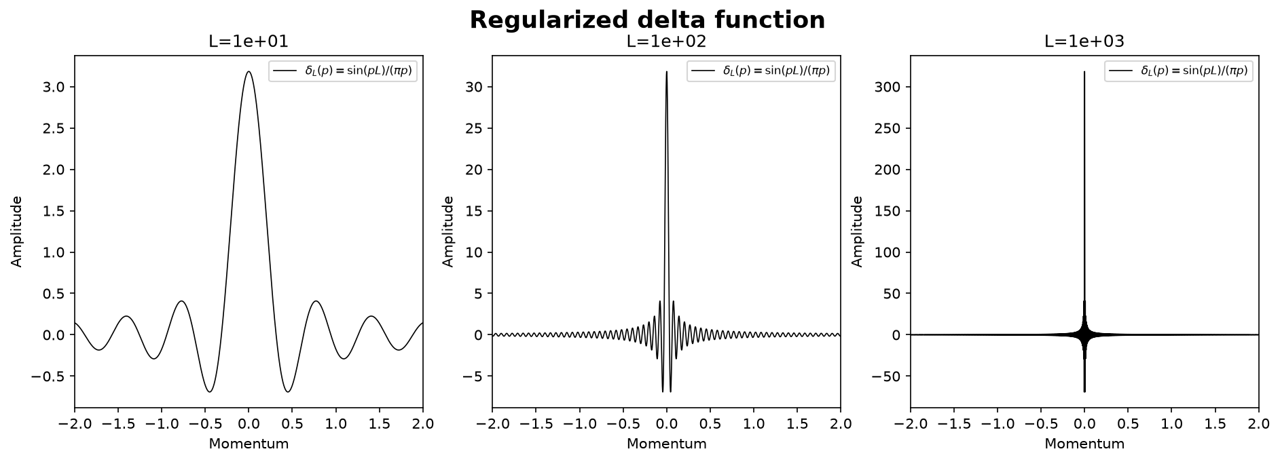
Figure 4. Finite-cutoff delta functions for L = 10, 100, and 1000.
As L increases, the central peak becomes higher and narrower and the side oscillations become more rapid.

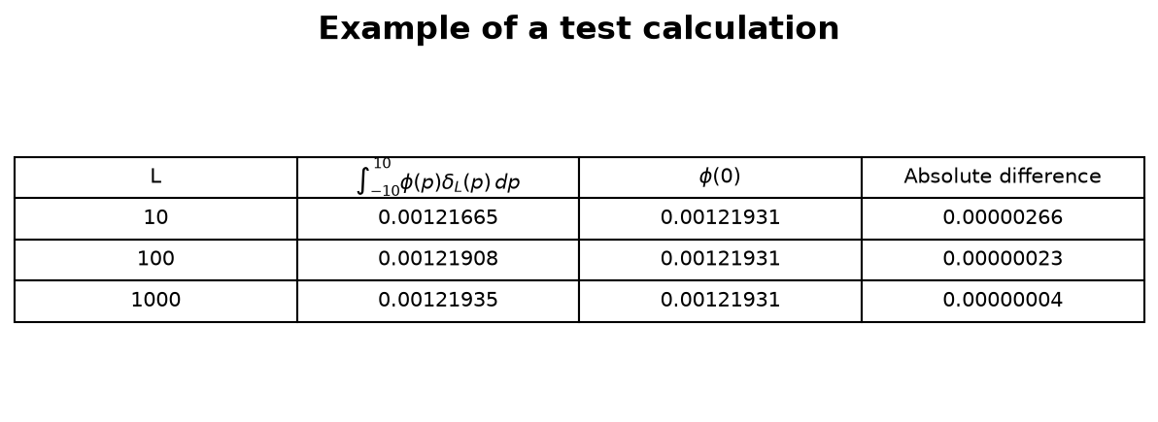
Figure 5. Numerical test of ∫ φ(p)δL(p) dp on the fixed interval [−10,10].
The target value is φ(0) = 0.0012193111. The absolute difference decreases from 2.66×10⁻⁶ at L = 10 to 2.26×10⁻⁷ at L = 100 and 3.70×10⁻⁸ at L = 1000. This confirms the expected delta-function behavior for the chosen smooth test function.

Part 3 — Stationary scattering and resonances
The scattering calculation uses the symmetric double-barrier potential:
V(x) = (x²/2 − 0.8) exp(−0.1x²),
which forms a central well between two barriers.
For each energy E, the stationary Schrödinger equation is solved numerically to obtain the transmission and reflection probabilities |T|² and |R|². The two resonance energies discussed below are identified from the transmission spectrum.
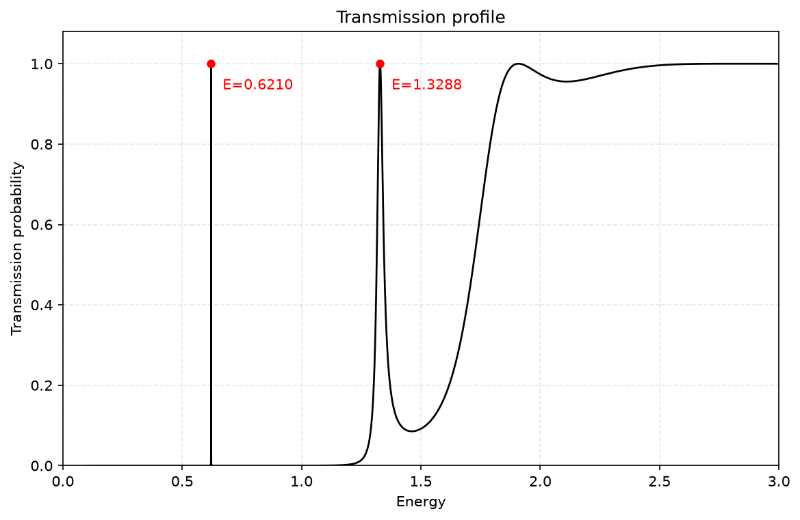
Figure 6. Transmission probability over 0 < E < 3.
The finite-difference maxima occur at E₁ ≈ 0.62097030 and E₂ ≈ 1.32882395. At both resonances, the transmission probability reaches almost one. The first peak is much narrower than the second, while at higher energies the transmission gradually approaches one.

3.1 Resonance peaks
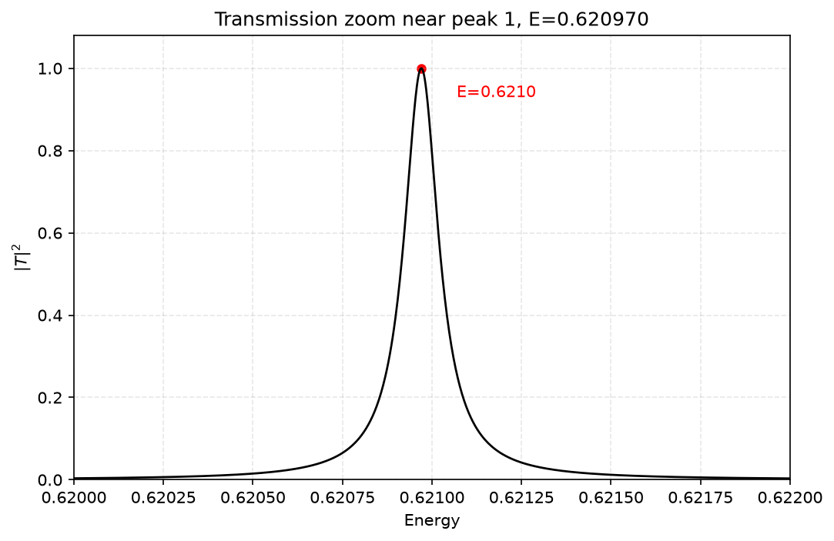
Figure 7. Zoom of the first transmission resonance peak.
A very small change in energy around E₁ ≈ 0.62097030 produces a large change in transmission. This shows that the first resonance is extremely narrow.

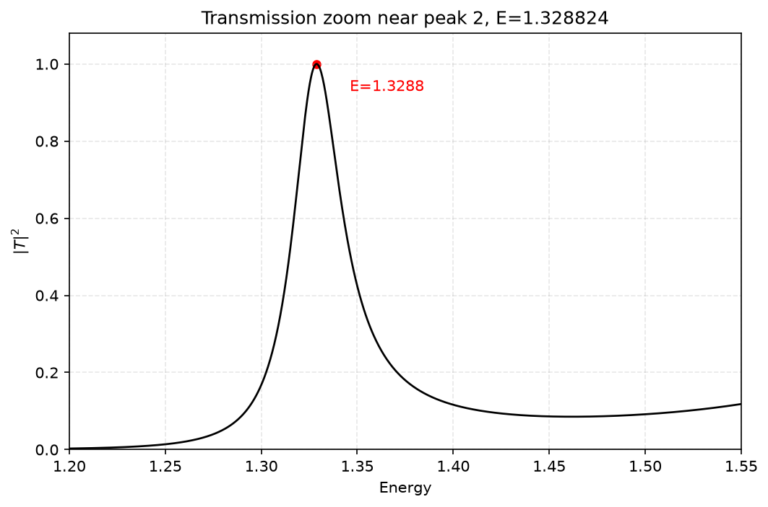
Figure 8. Zoom of the second transmission resonance peak.
The second peak is centered at E₂ ≈ 1.32882395. Compared with the first resonance, the peak is much broader.

3.2 Continuum wave functions around the two resonance peaks
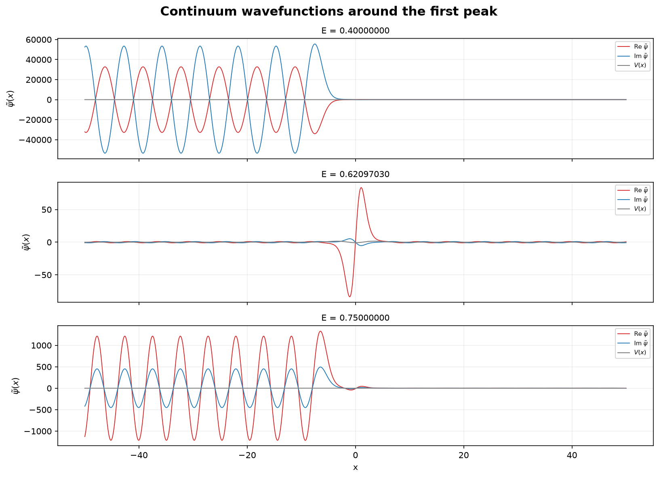
Figure 9. Wave functions around the first resonance peak.
First resonance. For E=0.40 and E=0.75, the wave is mainly reflected because the transmission probability is close to zero. At E≈0.62097030, the transmission rises to nearly one, so the wave passes through the potential almost completely. The resonance is also accompanied by a pronounced oscillation inside the central well.

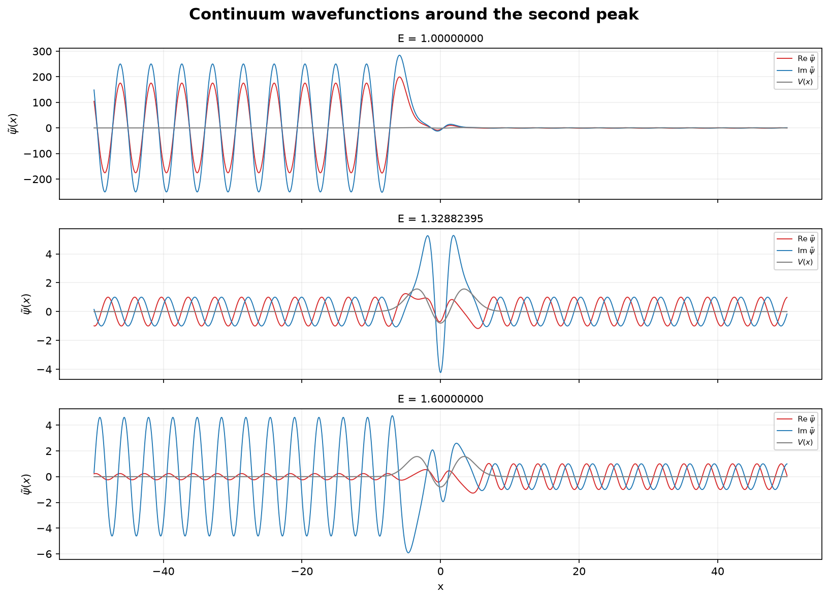
Figure 10. Representative raw continuum states around the second resonance.
Second resonance. At E=1.00 and E=1.60, the transmission is lower and a significant part of the wave is reflected. At E≈1.32882395, |T|²≈1, so the wave is transmitted almost completely through the potential. A pronounced oscillation also appears inside the central well.

Part 4 — Time-dependent scattering wave packets
The time-dependent wavepacket is constructed by adding the stationary scattering states from Part 3 with a Gaussian momentum distribution. Different momentum ranges are then chosen to demonstrate blocked, partially blocked, and pass cases.
Ψ(t,x) = ∫ dp Φ(p) ψp(x) exp(−i p²t/2).
In the figures, a0 is the momentum uncertainty. The figures also show √2 a0, which corresponds to the width parameter of the momentum-space Gaussian amplitude Φ(p).

4.1 Blocked
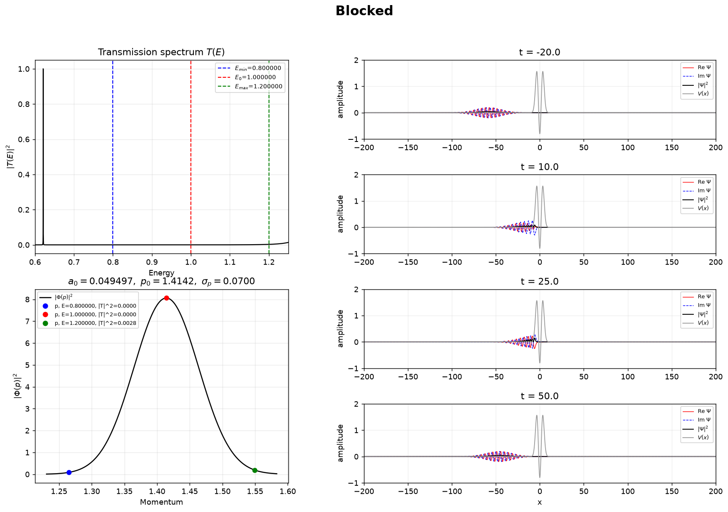
Figure 11. Blocked wave packet: E = 0.8–1.2, centered at E₀ = 1.0.
Almost the whole momentum distribution therefore lies in a low-transmission region. The packet approaches the potential and almost all of the packet is reflected.

4.2 Partially blocked
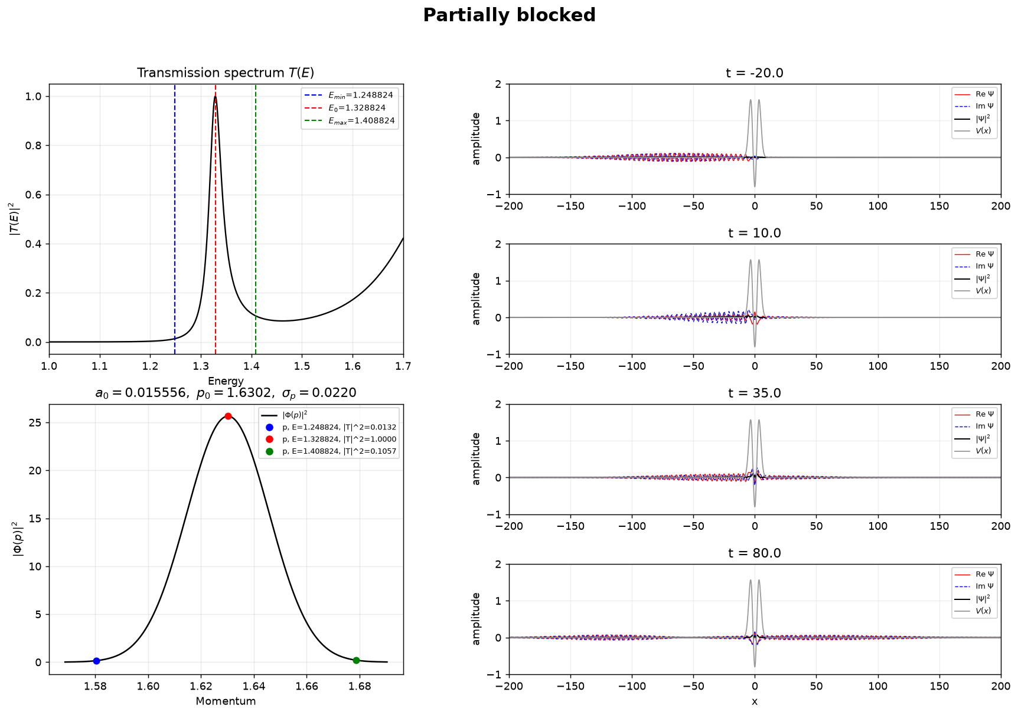
Figure 12. Partially blocked packet centered at the Part 3 second peak, E₀ = 1.32882395.
The center energy is exactly the Part 3 finite-difference value E₂=1.32882395, where the transmission is almost one. The edge markers have transmission probabilities of about 0.013 and 0.106. Because this wider packet contains both high- and low-transmission components, it separates into transmitted and reflected parts.

4.3 Pass
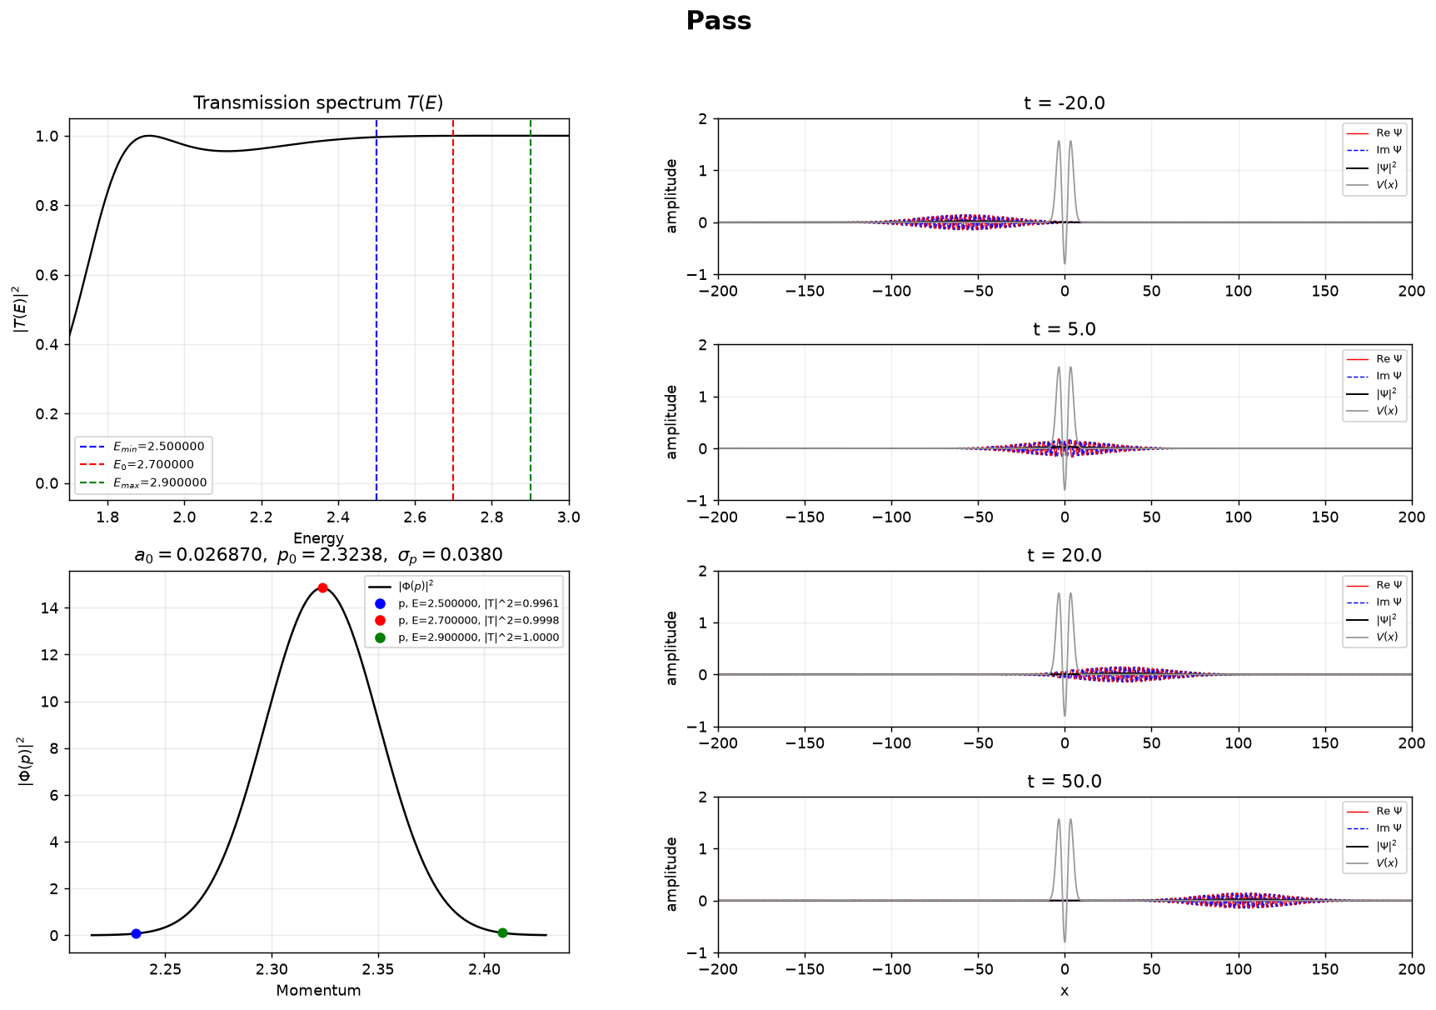
Figure 13. High-energy packet: E = 2.5–2.9, centered at E₀ = 2.7.
Across this interval the transmission probabilities are all almost 1. The wave packet therefore passes through the potential almost completely, with nearly no reflected part.

4.4 Narrow packet around the second resonance
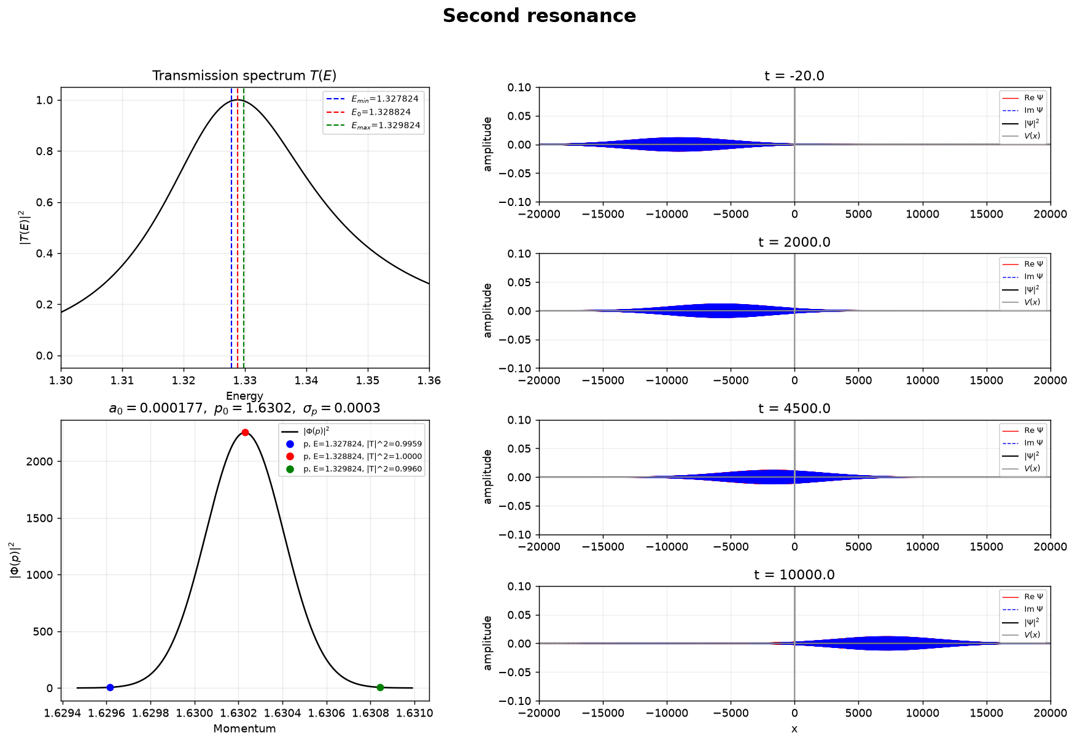
Figure 14. Narrow packet centered at the Part 3 second peak, E₀ = 1.32882395.
This calculation is centered on the same finite-difference value E₂=1.32882395 and uses a very narrow energy window. Nearly all spectral components have transmission close to one, and most of the wave passes through the potential. The very small momentum width also makes the packet very broad in real space.

